The Appeals policy is designed to protect the interests of all candidates and also to protect the integrity of the qualification.

Candidates have the right to appeal in the event that they are dissatisfied with the following:
- The assessment decisions made by The Northern College of Clinical Hypnotherapy, where applicable
- The assessment decisions made by the Awarding Organisations
- The decision by The Northern College of Clinical Hypnotherapy not to support an enquiry or appeal to the Awarding Organisation

A copy of the appeals procedure is available to all candidates.

There is an informal and formal procedure available. The formal procedure is only to be followed if the informal procedure has failed or is inappropriate for the circumstances. All appeals must be via the formal procedures of the Awarding Organisations and supported by the Director of Studies.

Every attempt will be made to resolve disputes as near as possible to the point of origin The Northern College of Clinical Hypnotherapy will keep appeals records for inspection by the Awarding Organisations
for a minimum of 18 months.

Informal Procedure

- Where a candidate wishes to make an appeal against the quality of provision at the college, he/she/they should first of all attempt to resolve the matter by a direct approach to the director of studies.
- If the matter remains unresolved the candidate may require a personal interview with the director of studies.
- Before the personal interview, the director of studies should have obtained an independent second opinion on the initial decision.
- If, after any action to resolve the dispute taken by the director of studies, the matter is not satisfactorily resolved, the complainant may use the formal procedure.

Formal Procedure

Once the informal procedure has been exhausted, of if it is inappropriate to the circumstances, the formal procedure is to be followed.

- The complainant will be required to submit a formal complaint in writing to the director of studies.
- Within 10 working days of receiving the written appeal, the decision of the director of studies should be communicated to the student/trainee.
- Decisions by the director of studies regarding the quality of teaching provision are final.
- If the complainant disagrees with the result of the formal Appeals procedure regarding assessment decisions, they may utilise the Awarding Organisations formal Appeals procedure for which they must be supported by the college. For details of the Awarding Organisation Appeals Procedure, please refer to the relevant Awarding Organisation website.

https://www.the-cma.org.uk/

https://www.ihahypnotherapy.com/

https://www.britishinstituteofhypnotherapy-nlp.com/

https://www.bsch.org.uk/

Further Appeals

Any learner wishing to appeal against the operation of the Appeals Procedure can do so in writing to the director of studies.

This policy has been approved & authorised by:

Name: Amanda Joy Harrison
Position: Director of studies
Date: 3/7/2021
Signature: 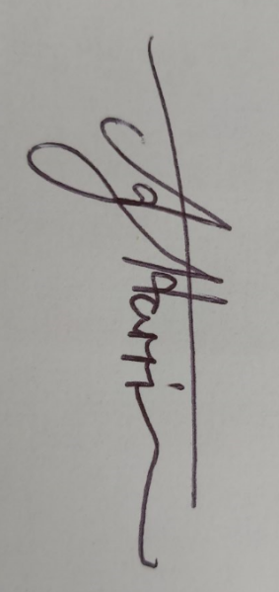
Review of Policy:3/7/2022

