Complaint – a grievance, problem, difficulty or concern

POLICY STATEMENT
The NCCH recognises the importance of learner complaints and welcomes complaints
as a valuable form of feedback about its services. We are committed to using the information we receive to help drive forward improvements.

This procedure outlines the aims of The NCCH in dealing with complaints and sets out what you as the customer can expect when making a complaint regarding a service.
A complaint is a way of letting us know that you are not happy with a particular service. We welcome your feedback. A complaint may be about delay, lack of response, discourtesy, failure to consult or about the standard of service you have received.

So please let us know if:

- you think we have done something wrong
- we have not done something that we said we would do
- you are not satisfied with a particular service or set of services that we provide

ANONYMOUS COMPLAINTS
We understand that it might be difficult for you to complain because you are worried that your complaint could result in a poorer service. Please be assured that we treat all complaints in the strictest confidence, and that it is your right to complain.
If you do not provide us with a contact name or address, it will not be possible for us to get back to you with the outcome of the investigation

PROCEDURE
In the first instance, the complaint should be discussed with the team member concerned and resolution sought within 48 hours of the incident occurring. If this is successful and a resolution is reached, the complaint should be documented on the attached Appendix (1) and sent to the Centre Administrator for filing. This should be received by the Centre Administrator by the end of the next working day. There will be no further action taken.

In the case of an individual wishing to make the complaint, who feels unable to discuss the complaint with the team member concerned, the matter should be referred to the Individuals’ line manager within 48 hours of the incident occurring. The line manager should then contact the Centre Manager within the next 7 days to make them aware of the complaint. The nature of the complaint will be documented as per Appendix (2) and sent to the Head of Learning and Development.

On receipt of the complaint, the nature of the complaint will be brought to the attention of the team member concerned and discussed within 48 hours of receiving the complaint. The Centre Manager will then contact the individual making the complaint with a view to resolve.

If resolution cannot be found, the Centre Manager will arrange a meeting with all relevant parties and agree a resolution. This will take place within 30 days. This will be final.

The Centre Administrator will maintain a record of all complaints and make these available on request. All complaints must be regarded as confidential and discussed only with those parties involved. Where the subject of the complaint is centred on a qualification, the Awarding Body will be made aware if this is relevant.
In the instance where the complaint is around an assessment / verification decision, then the stages outlined in the Appeals Procedure must be followed.

Appendix1

Record of Complaint

Name of Individual making the complaint: Location:
Date:

Nature of complaint

Resolution Agreed:

Signed Complainant: Date:

Signed by Centre Manager Date:

Apprendix 2

Referral of Complaint

Date of referral:………………………………………………………………………………………............. Line Managers Name: ……………………………………………………………………………………….

Nature of complaint:

Date Referred to Head of Assessment Centre:…………………………………………………...............

Actions agreed:

Signed off by Centre Manager:………………………………………………………….Date: Signed Complainant:……………………………………………………………………..Date

Name: Amanda Joy Harrison
Position: Director of Studies
Date: 3/7/2021
Signature: 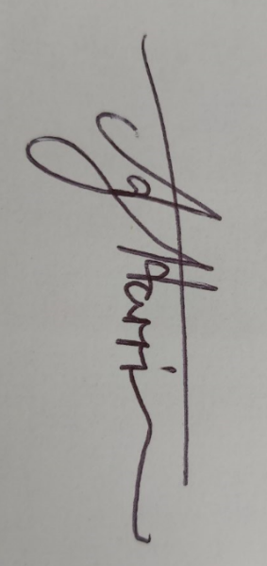
Review of Policy: 7/2022

